foreach input do {
// Rule 1: Check Rank, @ each step
if ∑ rank(input.front()) > 1 { too many operands }
if ∑ rank(input.front()) < 0 { too many operators }
// Rule 2: always write Operands
if (input.front() ∈ Operand) write(input.front());
// Rule 4: write operators until matching ‘(‘ is found on stack
else if (input.front() == RIGHT_PAREN ) {
while (stack.top() != LEFT_PAREN )
write(stack.pop());
stack.pop(); // Pop LEFT_PAREN
}
else if (input.front() == RIGHT_SQUARE_BRACKET ) {
while (stack.top() != LEFT_SQUARE_BRACKET )
write(stack.pop());
stack.pop(); // Pop LEFT_SQUARE_BRACKET
}

// Rule 3: greater precedence operators go on lower operators
else {
while (precedence(input.front() <= precedence(stack.top())) {
write(stack.pop());
stack.push(input.front());
}
}
// Rule 1: Check Rank, @ the end of all the input
if ∑ rank(input) != 1 { error ? }
// Dump stack when input is @ end
while (!stack.empty())
write(stack.pop);

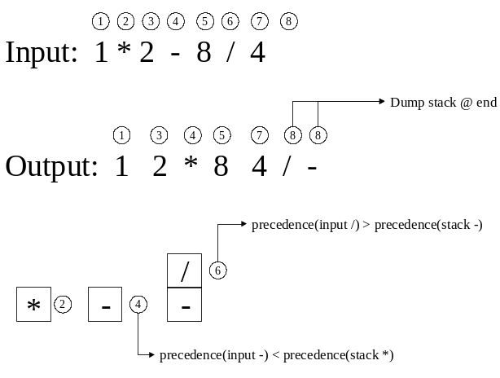

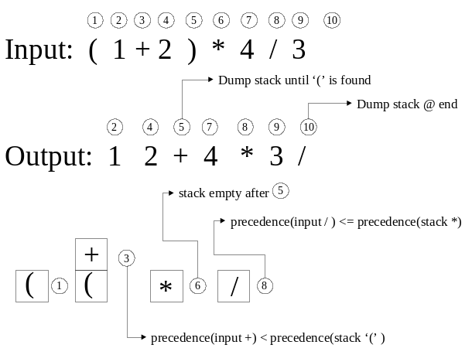
Input: j = i + k * e;

Output: j i k e * + =

Stack: = + *

Input: k + g > j * e

Output: k g + j e * >

Stack: +
> *

 | Precedence
Operator | Input | Stack
. ( [ | 15 | -1
) ] | 0 | 0
* / % | 13 | 13
+ - | 11 | 11
< > <= >= | 9 | 9
== != | 7 | 7
&& | 5 | 5
|| | 3 | 3
= | 1 | 1

Rule 1
Check Rank at each step
if ∑ rank > 1 too many operands
if ∑ rank < 0 too many operators

Rank of operand is 1
Rank of Operator is –1
Rank of ‘(‘ or ‘)’ is 0

Rule 2
Always write an operand
Constants or variables

Rule 3
Always evaluate higher precedence operators before lower precedence operators

Compare the precedence of an input operator to the precedence of an operator on the top of the stack

Rule 4
When ‘)’ is encountered dump Stack until matching ‘(‘ is encountered.
When ‘]’ is encountered dump Stack until matching ‘[‘ is encountered

Rule 5
Dump Stack when at the end of input data

Evaluate Infix Expressions

5^5^5

4 – 16 / (3 + 1) * 2

